*The Pleasure of Sad Songs*

By Leah Cotterell

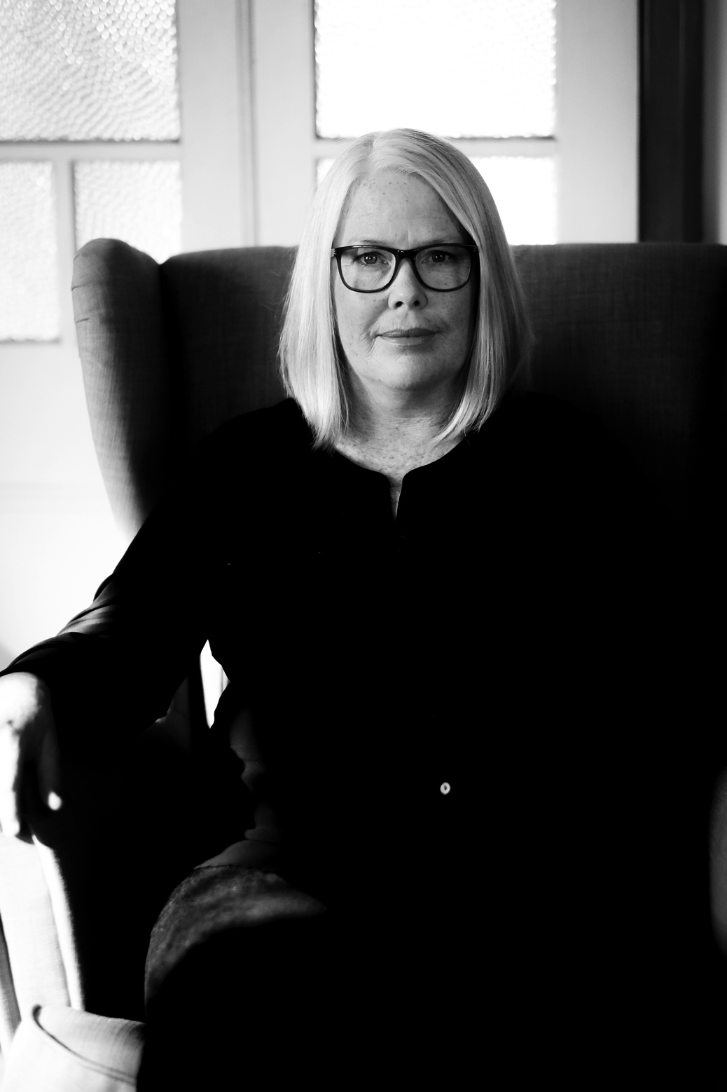

Photo by Robyn Mill

**Presenter’s Information**

Company Profile 2

About the show 2

Performance Specifics 4

Audience Engagement 5

Marketing 6

Production Details 9

Contacts 10

# Company Profile

Leah Cotterell has been performing and touring Australia for thirty years. In the last 15 years she has produced work for other artists that has toured regional Queensland and major interstate venues. In the last four years she has developed new work for her own performance that reflects on personal stories to deeply draw on her strengths as a singer, storyteller and producer. This new work ‘The Pleasure of Sad Songs’ deserves to find its audience nationally and internationally on the basis of its powerful and rewarding engagement with a timely subject, telling difficult stories with love and affection. The simplicity of the production with its embedded opportunities for meaningful community engagement has been especially developed for touring, with an emphasis on a community legacy of open conversations about mental health.

# About the show

### Synopsis

***The Pleasure of Sad Songs*** is a moving musical memoir of a family living with agoraphobia, schizophrenia and dementia. As a child carer, advocate and a witness to the journeys of her mother and brother, Leah Cotterell reflects on both the painful stigma of mental illness and the joys of recovery. In an act of love she celebrates the resilience of her family even as she struggles to manage their final transition into full time care. She considers this simple definition of mental health: the ability to work and to love. In 'The Pleasure of Sad Songs' Leah reflects not only on the complexity of loving people with mental illness but also the harsh ironies of dealing with mental health systems that don't work and can't love.

The show layers song, image and story in a journey of memory and emotion. Leah holds on to beauty and empathy to overcome the pain of disconnection. Her reflections flow back and forward, between the sparking of her imagination in childhood to the present with all its complex challenges. She maps the possible origin of her family’s trauma in the lives of the grandparents she never met and ultimately celebrates the value of memory in the face of irreversible forgetting. Through soulful singing and touching stories ‘The Pleasure of Sad Songs’ fights the stigma with laughter and shame with love.

### Acknowledgements

* Written and created by Leah Cotterell based on her family stories and images
* Performed by Leah Cotterell
* Accompanied by Steve Russell (TBC on a per show basis)
* Bookings managed by Annie Peterson for Women in Voice PresentsLeah Cotterell Biography

## Leah Cotterell Biography

*With a voice that is in turn lush, gravelly, deep, rich, lazy and powerful, Cotterell had us all eating out of the palm of her hand.* (The Australian, 1989)

*…the awesome raw power of blues in a stunning performance…*(The Australian, 1999)

*…it’s hard to believe there was anything, anywhere that could have been better   
than that emotional performance.* (The Courier Mail, 1999)

*Leah Cotterell could sing the shopping list and melt your heart.* (Rhythms Magazine, 2002)

### Performance history

Leah’s professional singing history begins in the vibrant alternative arts scene of Brisbane in the 80s with solo cabaret performances in ‘The Electric Frock’, and moves on to jazz in the 90s performing for national TV (Tonight Live and ABC Arts Programs), long running residencies and for Festivals. Later adventures include recordings with the Melbourne studio band ‘Black Taxi’, songwriting with Country Gospel band 18 Wheels and twenty years of performing and giving workshops at schools all over Australia with an a’capella trio Gypsy Tober for Musica Viva. Since 2014 Leah has been performing excerpts of ‘The Pleasure of Sad Songs’ based on her family story at conferences and events for special interest groups including mental health consumers, family carers and vocational educators as well as presenting the work at Woodford Festival (2015) and the Judith Wright Centre of Contemporary Art (2016). Leah also gives occasional concerts with ‘Tell Heaven’ a tribute to the folkloric traditions of black American gospel and bluegrass.

### Production history

As an independent producer of six music performance projects in collaboration with musicians and visual artists, Leah has managed and acquitted arts funding of over $251,623 including $71,417 from the Australia Council, $135,671 from Arts Queensland and Queensland Health and $27,235 from the Brisbane City Council. Her productions focus on telling stories of social importance through a blend of song, story and image and they include a local history of live music performance ‘Foolish Things’ 2005-2008 (Queensland Music Festival and Museum of Brisbane) and the story of six generations of a strong North Queensland Indigenous family, ‘Little Birung’ 2005-2012 (Cairns Indigenous Arts Fair, Judith Wright Centre, Artour).

### Community Engagement

Leah has been active in community engagement through her joint projects with mental health professional Helena Roennfeldt: as co-convenor of the ‘Music, Mental Health and Community Forum’ at The Queensland Conservatorium in 2016; providing singing workshops ‘Exploring singing as a medium for self-expression and connection’, at ‘Wellbeing Day’ coordinated by the Anglicare organisation: ‘A Place to Belong’ and at The Park Centre for Mental Health. Other community engagement includes workshops in regional communities for Music Viva and support work for the Access Arts Singers, a disability arts project.

### Post-graduate studies

Leah began her Doctor of Musical Arts research at the Queensland Conservatorium in 2016 with the support of an Australian Postgraduate Award Scholarship. She is researching the underlying mechanisms of emotion and empathy in singing through a study of other singers, in light of her own long and incredibly diverse experience. Her Masters research (2013-2015) was the mechanism by which she came to her own acceptance of grief leading to ground breaking new work and a research focus that continues in her Doctorate.

### Song writing

Leah began writing lyrics for music by Jamie Clark and Helen Russell in 1998 developing a number of stylistically diverse projects and producing jazz tunes, country rock, folk and gospel-influenced songs. A number of these songs have been re-recorded or performed by other singers including: ‘Hear Me and Remember’ (2012, Lou Bennett at the Four Winds Festival); ‘Fight On’ (2003 Combined Union Choir commissioned by Senator Claire Moore); ‘Small Blessings (2000, Alison St Ledger and various community choirs); and ‘Second Sight’ (1999, recorded by Katie Noonan and Elixir in 2003).

# Performance Specifics

### Duration

The full show is 80 minutes

Presentations have also been made at 10, 20, 30 and 60 minutes

### Suitable Venues

From black box venues to town halls and theatres, this show only needs a good blackout, a few focused lights and a projection system. A good piano is optional.

### Maximum Number of Shows per week

6 single venues or 8 if in same venue

### Minimum break between performances

120mins

### Licencing Agreements

The creator owns the work

### APRA Obligations

Royalties are paid through the venues APRA licence for these songs:

*Supper Club*  
Music Jamie Clark, Words Leah Cotterell 2003

*The Final Stroke*   
Music Jamie Clark, Words Leah Cotterell 2009

*Red Rose*Music Jamie Clark, Words Leah Cotterell 2009

*The Long Day*Music Helen Russell, Words Leah Cotterell 2014

*Let the Great Big World Keep Turning*Music Nat Ayar, Words Clifford Grey 1917

*Stardust*Music Hoagy Charmichael, Words Mitchell Parrish 1927

*Red Sails in the Sunset*Music Williams, Words Kennedy 1935

*God Bless the Child*Music Herzog, Words Holiday 1939

*Annie’s Song*Music and Words John Denver 1973

*The Carnival is Over*Russian folk melody, lyrics Springfield 1965

*The Pleasure of Sad Songs*Music Helen Russell, Words Leah Cotterell 2014

*Now*Music Jamie Clark, Words Leah Cotterell 2008

*Small Blessings*Music Helen Russell, Words Leah Cotterell and Meg Kanowski 1999

### Touring Personnel

The touring party consists of 3 people.

|  |  |
| --- | --- |
| Name | Role |
| 1. Leah Cotterell | Singer |
| 2. Various - one of these fine musicians: Steve Russell, Jamie Clark and Dave McGuire | Accompanist |
| 3. TBC | LX and Audio Operator |

### Performance History

|  |  |  |
| --- | --- | --- |
| Year | Venue | Number of performances |
| 2014 | Ian Hanger Recital Hall, Queensland Conservatorium | 1 |
| 2015 | Women in Voice, Concert Hall, Queensland Performing Arts Centre | 1 – 20 mins excerpts |
|  | King Kray Cabaret, Princess Theatre, Woolloongabba | 1 - 20 mins excerpts |
|  | Sanity Fair, Musgrave Park, West End | 1 - 30 mins excerpts |
|  | Standing Beside You, Carer’s Week Forum, Brisbane Convention Centre | 1 – 10 mins excerpts |
|  | Woodford Folk Festival 2015 | 2 |
| 2016 | TAFE Excellence in Education Conference, Brisbane Convention Centre | 1 – 20 mins excerpts |
| May | Music, Mental Health and Community Forum, Ian Hanger Recital Hall, Queensland Conservatorium | 1 – 10 mins excerpts |
| September | TAFE Service Conference | 2 – 40 mins excerpts |
| October | Judith Wright Centre of Contemporary Art | 2 |

# Audience Engagement

### Overview

1. Voice Workshops:
   1. Beginners: Singing skills for pleasure and for healthy self-expression
   2. Masterclass: Stagecraft, storytelling and the world of the song
2. Moderated workshops about creativity and singing, communication and wellbeing in a mental health context

### Description

* 1. This is a two-hour exploration of vocal and performance technique that can be pitched to the optimal level of engagement for the group attending. Activities may include an overview of bringing your body to life, warming up your sound, learning fun group repertoire, conversations about the purpose and pleasures of singing, tailored advice on performance and staging.   
     (Minimum 5, Maximum 20)
  2. How do we engage with empathy in performance? How do we enter the world of the singer? What can a performer do to deepen their connection to the world of the song? In this workshop Leah guides the participants to reflect on what they are seeking to share with their audience, how they are offering that to the audience, and why. This workshop is based on Leah’s contemplation of the underlying mechanisms of emotion induction and empathy in music: the heart of her own soulful performances and the subject of her Doctoral research.

1. In these interactive workshops, Leah will be joined by her collaborator Helena Roennfeldt. These group processes are targeted to mental health consumers, carers, administrators and workers. Outcomes may include research and reporting. Requirements may include a safe space and confidential interactions that conform to appropriate ethical processes. These workshops have been developed with expert input and trialled with mental health consumers and may attract funding from community organisations or health and Government programs.  
   (Minimum 5, Maximum 20) Cost
2. $25 per head
3. Set fee to be negotiated

### Target audience for engagement

1. All ages
2. Interested adults, community groups and individuals

# Marketing

### Marketing Copy

### One line

Celebrating courage, compassion and the healing power of song.

### Short

*The Pleasure of Sad Songs* is a moving musical memoir of a family living with agoraphobia, schizophrenia and dementia. As a carer, advocate and witness to the journeys of her mother and brother, Leah Cotterell reflects on both the painful stigma of mental illness and the joys of recovery even as she struggles to manage their final transition into full time care. She considers this simple definition of mental health: the ability to work and to love. In 'The Pleasure of Sad Songs' Leah reflects not only on the complexity of loving people with mental illness but also the harsh ironies of dealing with mental health systems that don't work and can't love.

### Extended

*The Pleasure of Sad Songs* is a moving musical memoir of a family living with agoraphobia, schizophrenia and dementia. As a carer, advocate and witness to the journeys of her mother and brother, Leah Cotterell reflects on both the painful stigma of mental illness and the joys of recovery even as she struggles to manage their final transition into full time care. She considers this simple definition of mental health: the ability to work and to love. In 'The Pleasure of Sad Songs' Leah reflects not only on the complexity of loving people with mental illness but also the harsh ironies of dealing with mental health systems that don't work and can't love.

Leah emerged from shadow of early trauma on the wings of song. It took years to find the courage to sing professionally but when she did she made immediate success: *With a voice that is in turn lush, gravelly, deep, rich, lazy and powerful, Cotterell had us all eating out of the palm of her hand.* (The Australian, 1989).Over thirty years she has pursued a life of creative experimentation, singing and producing and honing her songwriting craft. But ultimately it is the soulful sound she makes that makes her singing so memorable: *Leah Cotterell could sing the shopping list and melt your heart.* (Rhythms Magazine 2002)

Leah began her Doctor of Musical Arts research at the Queensland Conservatorium in 2016 researching the underlying mechanisms of emotion and empathy in singing through a study of other singers, in light of her own long and incredibly diverse experience. Her Masters research (2013-2015) was her inspired response to the depression she experienced when her mother’s dementia triggered her brother’s extended stay in acute care. Once again creativity was the mechanism by which Leah came to her own healing and acceptance of grief and pain. That’s the pleasure of sad songs.

*Listen to Leah's interview with Sarah Kanowski on ABC Radio's Conversation series:*[*http://www.abc.net.au/local/stories/2015/07/24/4280008.htm*](http://www.abc.net.au/local/stories/2015/07/24/4280008.htm)

## Marketing Summary

Target community interest groups and networks include:

* Mental Health consumers
* Community support organisations
* Family carers
* Health workers
* Musicians, music students and choirs
* Older audiences

This is a human-interest story that offers lots of opportunities for conversation in the community. Leah is a colourful raconteur and a warm presence in all mediums, particularly radio and online.

### Online assets

* Leah’s blogs are here: <http://www.leahcotterell.com.au/#!blog/c23mc>
* Her YouTube channel has a great range of music clips and montages: <https://www.youtube.com/user/leahcotterell>
* Listen to Leah's Interview with Sarah Kanowski on ABC Radio's Conversation series: <http://www.abc.net.au/local/stories/2015/07/24/4280008.htm>

### Audience Reviews

*...this is storytelling of real courage, authenticity and compassion...*

(Katie Noonan, Woodford Performance 2015)

*Each song was like a gift, a jewel on a garment - another way of knowing.*

(Showcase audience 2014)

*“incredibly powerful”, “poetic” and “full of inspiring truths”*

(King Cray Cabaret 2015)

*Leah has a rare gift of being able to gently tell her story in a genuine and matter of fact manner, showing her wisdom, humility and resilience.*

(Carer's Week Forum 2015)

*It was a privilege to hear your story, which you shared so openly and beautifully.*

(TAFE Educator's Conference 2016)

### Video Links

Title song: <https://www.youtube.com/watch?v=IgOEBlxtmNA>

Closing song: <https://www.youtube.com/watch?v=yoeAqcjg-W0>

Broadcast footage is in development in 2016

### Images

Portraits by Robyn Mill 2016

|  |  |  |
| --- | --- | --- |
|  |  |  |

Mavis Cotterell (Leah’s Mother) c 1950:

|  |  |  |
| --- | --- | --- |
|  |  |  |

For hi-res copies email [leahcotterell@gmail.com](mailto:leahcotterell@gmail.com)

### Marketing Materials

* Poster and flyer art – new work in development
* Sound recordings
* Video

### Content Warnings

No warnings, but audience are invited to interact with the artist *specifically* to support people who may have issues they wish to discuss after viewing the performance.

### Sponsor acknowledgements

This is an independent production. Only the agent and venues logos need to be displayed.

# Production Details

### Technical Summary

The audio is simple and vitally important and so must be well balanced and clear. A few focused specials and mood evoking general states are sufficient for a full presentation while less formal or adapted excerpts can be presented in any light conditions that allow for the AV elements. screen and data projector are sufficient except if presented at a day time or open air event the preferred mode of visual presentation  would be a TV Monitor.

### Example Schedule

Unload equipment 0.30 mins

If required, focus lights 1.00 hour (may have occurred before arrival)

Set lights cues and check sound 1.00 hour

Check AV 0.30 mins

TOTAL 3.00 hours

### Crew required from venue

Duty manager able to set lights and sound and operate where necessary

### Stage

Onstage elements include:

* The accompanist with their instrument Stage Right
* A minimal set including a chair and three suitcases Stage Left
* The vocal mic set on a stand in the Centre

Leah will supply the set elements

*Venue to supply*

* Vocal microphone and stand
* Tuned quality piano (where available)
* Vintage armchair (where available)

### Lighting

* Specials for three areas SR, SL and centre
* A number of cool and warm general washes can be set in the bump in

Leah will supply a script with lighting cues

### Sound

The sparing musical elements of the work are central to the experience so a quality sound system tuned to the space is essential.

*Venue to supply*

* Vocals: Leah requires a quality headset microphone as well  as a quality vocal microphone.
* Steve would be thrilled to find a quality, recently tuned piano in the venue but travels  with a high quality electronic piano

Leah can supply headset and receiver if necessary

### AV

The performance features 20 stills and 10 movies to be projected – Leah will operate these cues. Leah will supplycomputer and peripheral connections for VGA and HDMI cables.

*Venue to supply*

* Projection system with screen at rear of stage with cabling to the stage for visual display
* If presented at a day time or open air event the preferred mode of visual presentation would be a TV Monitor (57” minimum)

### Wardrobe

Wardrobe is simple and drip dry – no special arrangements are required

### Freight Notes

This production will travel in one station wagon, carrying a small PA and keyboard as a back up system.

# Contacts

|  |  |  |
| --- | --- | --- |
| Leah Cotterell | Performer | [leahcotterell@gmail.com](mailto:leahcotterell@gmail.com) - 0432 092 936 |
| Annie Peterson | Agent | [annie@wivpresents.com](mailto:annie@wivpresents.com) - 0417 768 487 |